NAME: RAGAVI V REG NO: 192511212
COURSE NAME: JAVA COURSE CODE: CSA0924
1.Read a candidate's written-test score and interview score. Calculate the weighted score using 70% and 30%, then determine selection status.

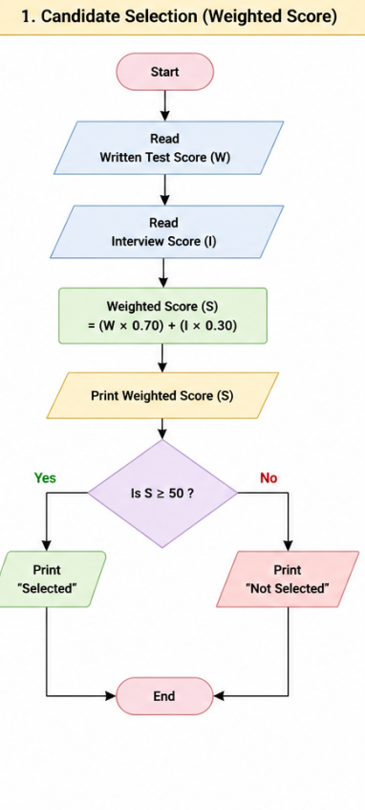

PSEUDOCODE:
START
INPUT writtenTestScore
INPUT interviewScore
weightedScore = (writtenTestScore * 0.70) + (interviewScore * 0.30)
PRINT "Weighted Score = ", weightedScore
IF weightedScore >= 50 THEN
PRINT "Status: Selected"
ELSE
PRINT "Status: Not Selected"
END IFSTOP

CODE:
import java.util.Scanner;
public class CandidateSelection {
public static void main(String[] args) {
Scanner sc = new Scanner(System.in);

// Input scores
System.out.print("Enter Written Test Score: ");
double writtenTestScore = sc.nextDouble();

System.out.print("Enter Interview Score: ");
double interviewScore = sc.nextDouble();

// Calculate weighted score
double weightedScore = (writtenTestScore * 0.70) + (interviewScore * 0.30);

// Display weighted score
System.out.println("Weighted Score = " + weightedScore);

// Determine selection status
if (weightedScore >= 50) {
System.out.println("Status: Selected");
} else {
System.out.println("Status: Not Selected");
}

sc.close();
}
}

2. Read N integers into an array and determine whether the array is a palindrome.

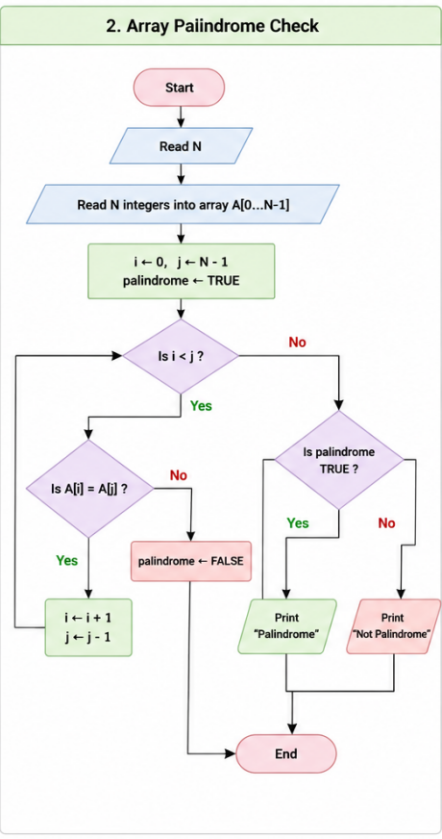

PSEUDOCODE:

START
INPUT N
DECLARE array A[N]

FOR i ← 0 TO N-1
INPUT A[i]
END FOR

palindrome ← TRUE

FOR i ← 0 TO N/2 - 1
IF A[i] ≠ A[N-1-i] THEN
palindrome ← FALSE
BREAK
END IF
END FOR

IF palindrome = TRUE THEN
PRINT "Array is a Palindrome"
ELSE
PRINT "Array is Not a Palindrome"
END IF

STOP

CODE:
import java.util.Scanner;
public class ArrayPalindrome {
public static void main(String[] args) {
Scanner sc = new Scanner(System.in);
// Read array size
System.out.print("Enter the number of elements: ");
int n = sc.nextInt();
int[] arr = new in
// Read array elements
System.out.println("Enter the array elements:");
for (int i = 0; i < n; i++) {
arr[i] = sc.nextInt();
}
boolean palindrome = true;
// Check palindrome
for (int i = 0; i < n / 2; i++) {
if (arr[i] != arr[n - 1 - i]) {
palindrome = false;
break;
}
// Display result
if (palindrome) {
System.out.println("Array is a Palindrome");
} else {
System.out.println("Array is Not a Palindrome");
}
sc.close();
} }
3.Design a student-fee flowchart with functions for tuition fee, hostel fee, scholarship deduction, and net fee. Map it to a Java Student Fee class

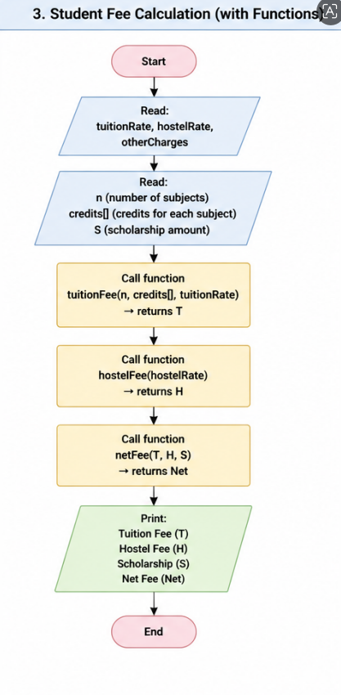

PSEUDOCODE:
START

FUNCTION tuitionFee(t)
RETURN t

FUNCTION hostelFee(h)
RETURN h

FUNCTION scholarshipDeduction(s)
RETURN s

FUNCTION netFee(t,h,s)
RETURN tuitionFee(t)+hostelFee(h)-scholarshipDeduction(s)

INPUT t,h,s
PRINT netFee(t,h,s)

STOP

CODE:
import java.util.Scanner;

class StudentFee {
double tuition, hostel, scholarship;

StudentFee(double tuition, double hostel, double scholarship) {
this.tuition = tuition;
this.hostel = hostel;
this.scholarship = scholarship;
}

double tuitionFee() {
return tuition;
}

double hostelFee() {
return hostel;
}

double scholarshipDeduction() {
return scholarship;
}

double netFee() {
return tuitionFee() + hostelFee() - scholarshipDeduction();
}
}

public class Main {
public static void main(String[] args) {
Scanner sc = new Scanner(System.in);

System.out.print("Enter Tuition Fee: ");
double tuition = sc.nextDouble();

System.out.print("Enter Hostel Fee: ");
double hostel = sc.nextDouble();

System.out.print("Enter Scholarship Amount: ");
double scholarship = sc.nextDouble();

StudentFee s = new StudentFee(tuition, hostel, scholarship);

System.out.println("Net Fee = " + s.netFee());

sc.close();
}
}

